Statement of environmental effects.
- Site Suitability
Constraints.
Flooding.
Consulted Lockhart Flood Study July 2014. Site is in the floodway on the South East Corner levels between 0.1-0.2 (m) with the North West Corner levels between 0.5-1.0 (m)
This aligns with anecdotal evidence from previous tenants that noted to us the levels during the flooding in 2010 and 2012.
In consideration of flooding due to proximity to the creek and accompanying effects of the gradient of the site, the ability to mitigate any risk of inundation by raising any stock on hand to levels well above flood height will be exercised. The use of secured racking or the natural high ground on site are both appropriate measures to ensure avoiding inundation.
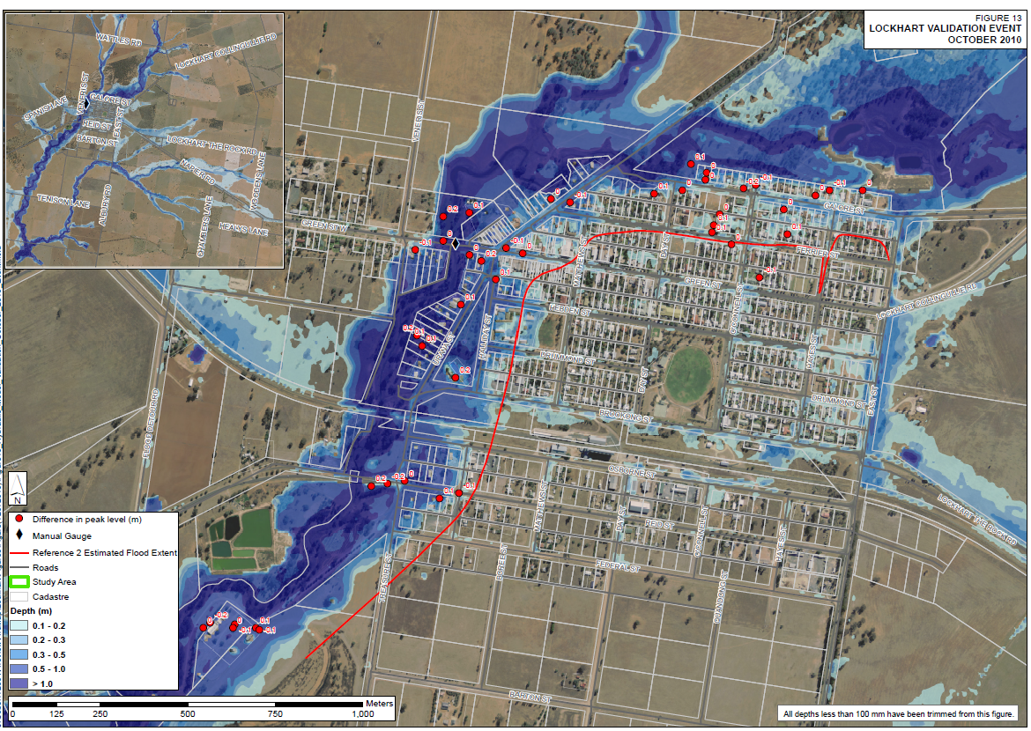

Slope.
Part of this flooding is explained by the proximity to the Brookong Creek, and part is due to the gradient of close to 1% from the lowest points on the West to the highest point on the Eastern Edge.
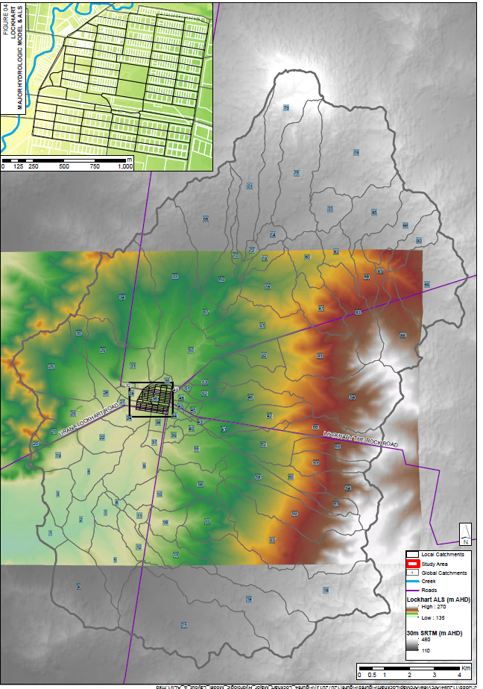
Bushfire
Riverina Bushfire Risk Management Plan, Overview of District.
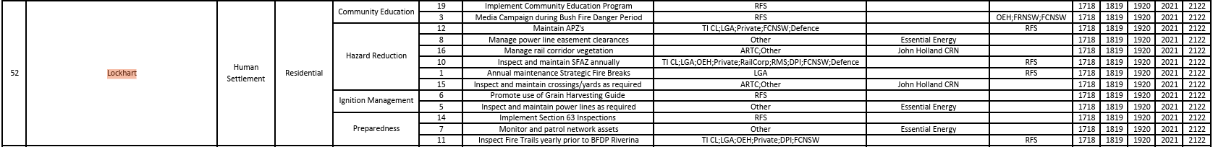
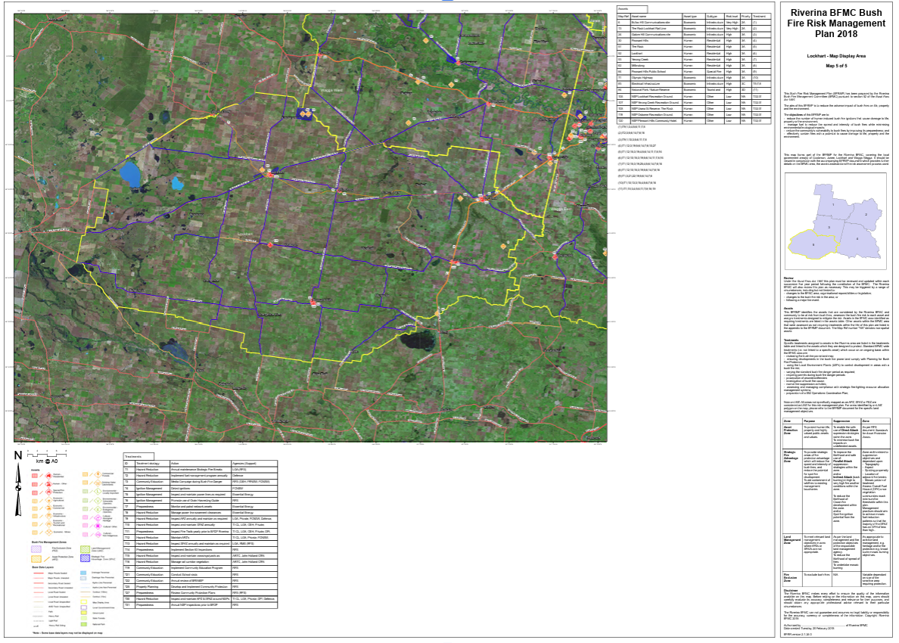

Overview of site, specific.
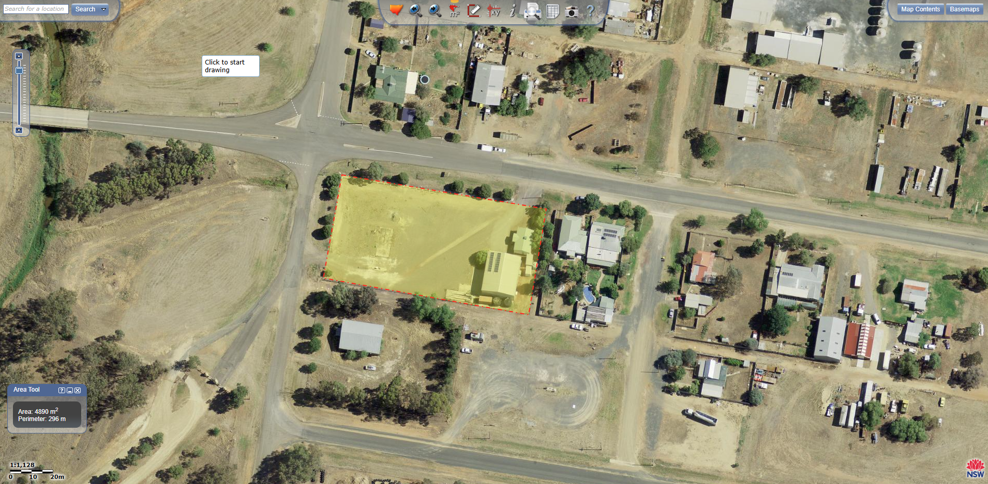
Bush Fire: a general term used to describe fire in vegetation, includes grass fire.
Assets on site or adjacent at risk of bushfire. Fence line, Sheds, Office, Rainwater Tanks, Trees, Grass and natural vegetation.
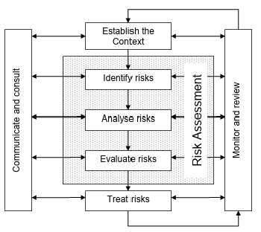
Management Strategies.
Gras on site will be kept at a low or nil level to minimise fuel load and chance of grass fire.
Site Protection Plan: a fine scale document that that consists of map and preparation documents will be kept on hand.
Fire Fighting Equipment. As a part of the business, we are likely to retail fire fighting pumps and associated equipment and as such can utilise water carts and tanks on site in the event of a fire.
Risk Identification. We will continually monitor for risks increasing or decreasing such as native vegetation accumulating on or around out site, identify remove of remediate these risks with consultation to the appropriate authorities.

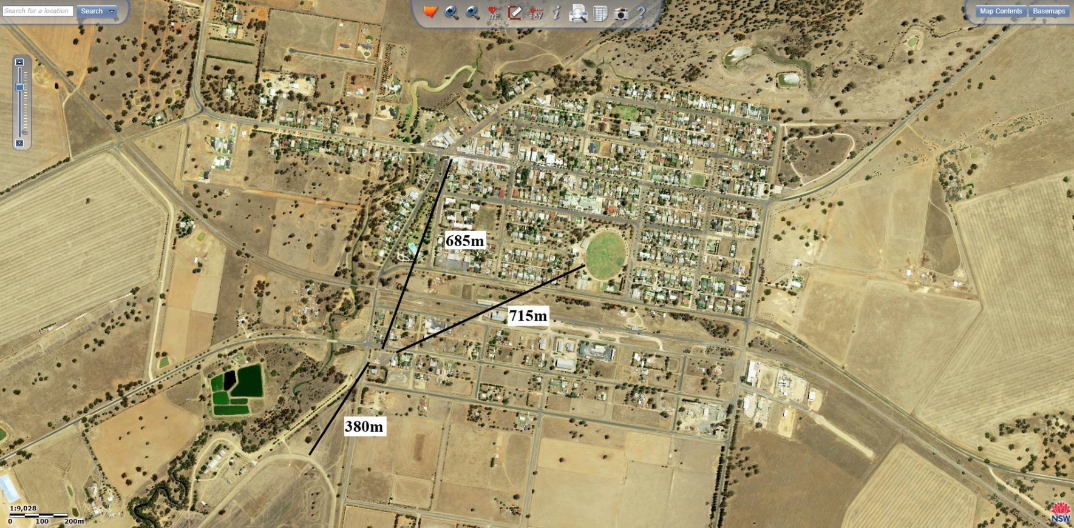
Proximity to shops, community and recreation facilities.

685m to closest shop on Green St.
715m to Recreation Ground.
380m to Racecourse / Show Grounds.
Our closest proximity to the community is two residential lots to the East.
The site is compatible with adjoining developments.

The site is suitable with local planning objects, after referencing the Local Strategic Planning Statement 2020 – 2040, especially under the LSPS Priorities of Growing a diverse economy and Strong, connected and healthy communities.
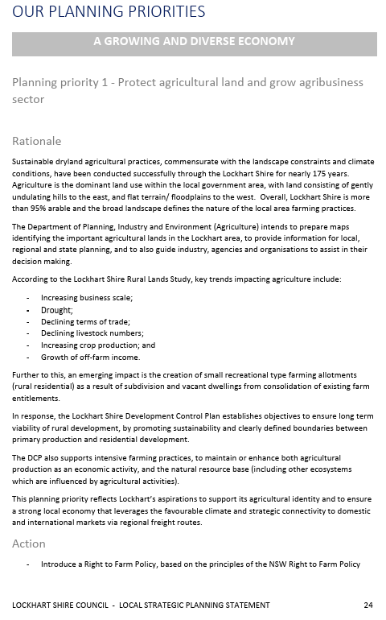
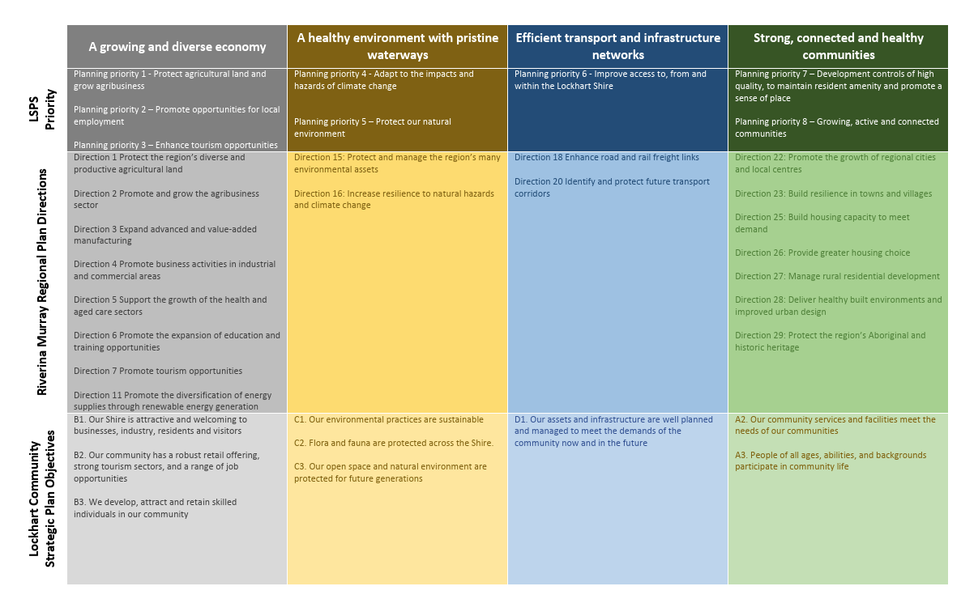
Planning priority 1 – Protect agricultural land and grow agribusiness sector and Planning Priority 2 – Promote opportunities for local employment will both be met by this new business, a locally, family owned and operated agribusiness.
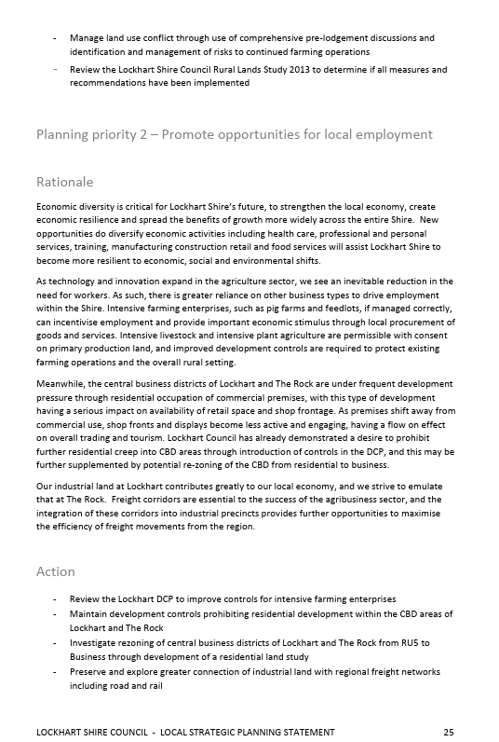
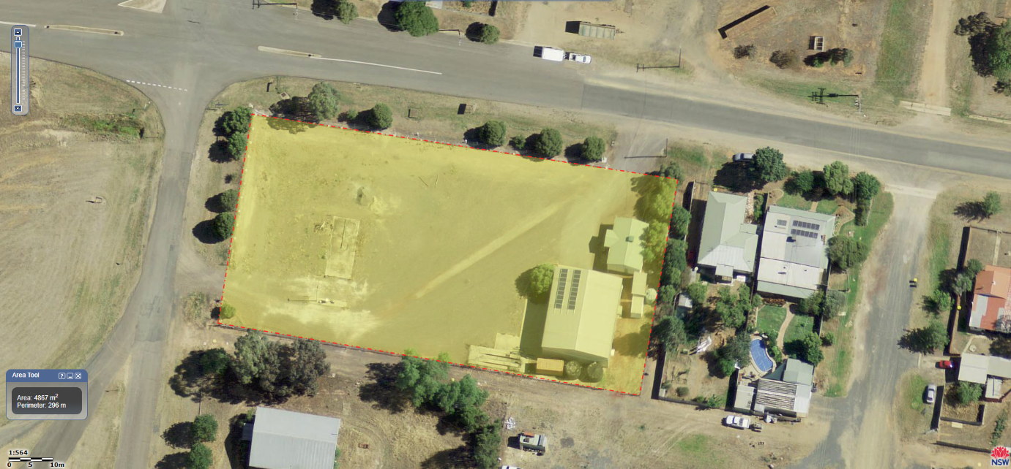
Size and Shape of allotment.
Shed and office are in good to excellent condition and are from 2005

- Current and Previous Uses.
The previous use of the site was as a heavy haulage depot.
The present use has not yet commenced.
Adjoining land is vacant council land sloping to the Brookong Creek on the Western Edge.
Reid St on the Northern Edge adjoining land is general industrial.
Eastern adjoining blocks are residential.
Southern Edge adjoining blocks are vacant scout hall south west and general storage shed south east.
We are currently not aware of any potential contamination on the site.

- Operational Details.
Hours of operation initially will be 9-5 Monday to Friday, potentially extending those during busy seasons, predominantly during preparation for establishment of the cropping phase on farms.
Type of business: Agribusiness retail and agronomy.
Number of staff: 2 current.
Hours and days of operation 9am-5pm Monday to Friday
Plant and Machinery: Forklift, HR single Curtain sider Truck, Utes.
Production Processes: Nil
Type and quantity of raw materials, finished products and waste products: Nil
Identify any proposed hazardous materials or processes: Processes Nil
Hazardous materials proposed include Schedule 5,6, and 7 chemicals.
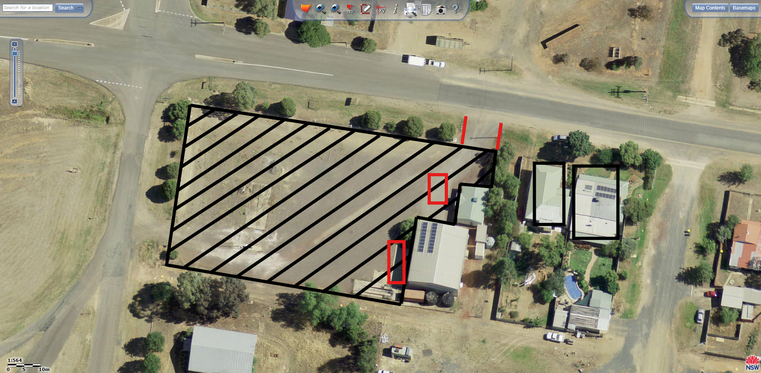
- Access and traffic.
Disability access. Planned installation of handles on front steps of office.
Pedestrian amenity. N/A.
Bicycle facilities. N/A.
Vehicle Access to public road. Access via double gate to REID St.
Parking on site. Large gravel yard, parking available for 15 vehicle, concrete apron on west of shed, Parking available for 4 vehicles, and also option to park 2-3 vehicles in the shed.
Truck Park on concrete apron = 1 park
Parking calculations. 2 Staff in one vehicle most days = 2 parks
2 Staff in separate vehicles on occasional days = 3 parks
Potential for additional staff in additional vehicle = Max 4 parks
No major traffic generation.

- Air and Noise.
Proposed air and noise mitigation.
Gravel yard to mitigate any dust.
Operational hours between 9-5, occasionally from 8am to minimise noise.
Operational noise. N/A
Expected traffic is only 1-2 Utes every other day and the occasional MR truck plus occasional forklift use.
- Privacy, Views and Overshadowing.
There will be no structural changes to the site and so there will be no effects.

- Visual Privacy.
Window placement. Existing windows in demountable office on Eastern side facing neighbours, blinds can be drawn and there is a row of trees to be kept in place running north south between our security fence and the corrugated fence that almost completely obscure any vision between the blocks.
Views between living rooms, and private yards of other dwellings. N/A
Use of screen planting walls or fences to improve privacy. N/A
Flood lights and light spillage. N/A

- Acoustic privacy.
Placement of active use outdoor areas relative to bedrooms marked in black stripes in markup above.
Separation of roads, parking areas and driveways (Marked in red existing driveways and parks)
Noise transmission between dwellings will be minimal with the majority of operational noise coming from a single fork lift operating at 85 decibels inside the shed and occasionally outdoors between the hours of 9am-5pm.
Measures to mitigate external noise sources are noted above as such.
- Views
Impact of proposed development on views from adjoining nearby properties. N/A
Design options for protecting views. N/A
Views from the proposed development. Unchanged

- Overshadowing
N/A

- Soil and Water
Water Supply. Rainwater tanks on site.
Sewerage disposal. Septic tank on site.
Drainage. Site will drain into adjacent table and stormwater drains in the directions noted below.
Flooding. As above in section 1
Erosion and sediment control. Site is gravelled and packed and on very minimal gradient to minimise any and all erosion and sediment.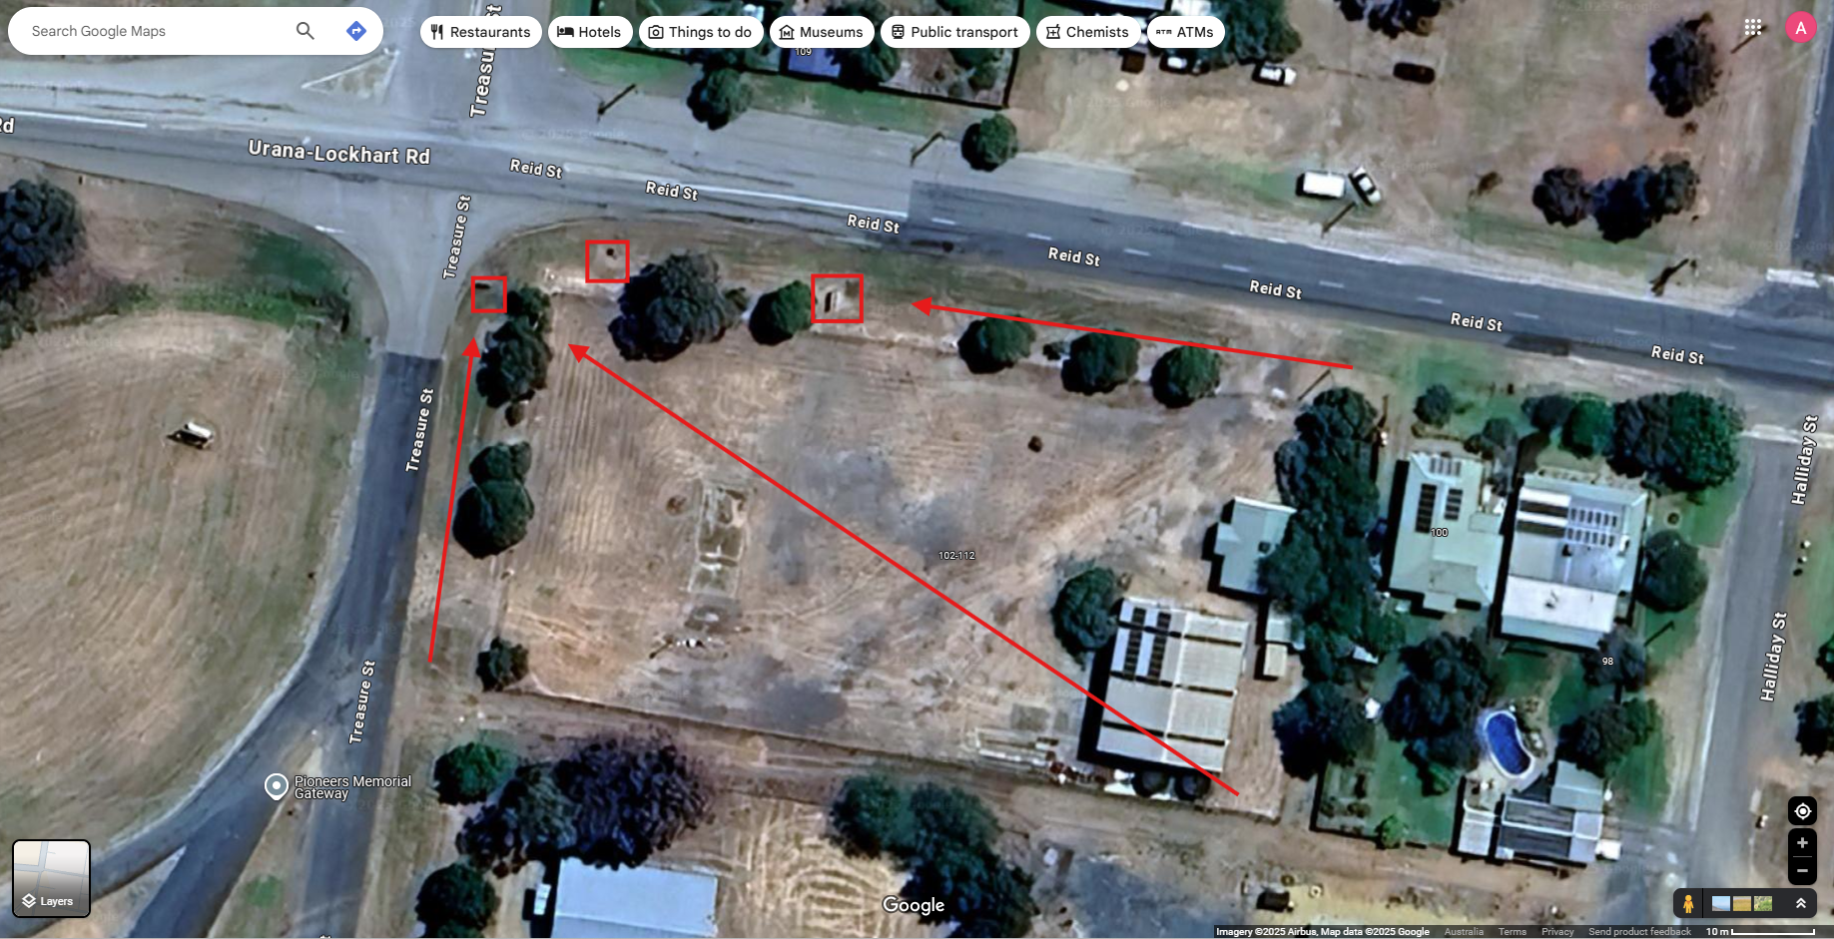

- Heritage.
N/A
- Flora and Fauna.
N/A
- Waste.
Proposal will minimise waste using recycling of cardboards, glass and aluminium.
- Energy.
Minimal staff using natural sunlight in office.
Shed had translucent corrugated strips to allow natural sunlight and avoid lighting.
Shed has solar panels installed.

